# Algorithm for file updates in Python

## Project description

Scenario:

As a security professional working at a health care company, I am required to regularly update a file that identifies the employees who can access restricted content. The contents of the file are based on who is working with personal patient records. Employees are restricted access based on their IP address. There is an allow list for IP addresses permitted to sign into the restricted subnetwork. There's also a remove list that identifies which employees you must remove from this allow list.

Your task is to create an algorithm that uses Python code to check whether the allow list contains any IP addresses identified on the remove list. If so, you should remove those IP addresses from the file containing the allow list.

## Open the file that contains the allow list

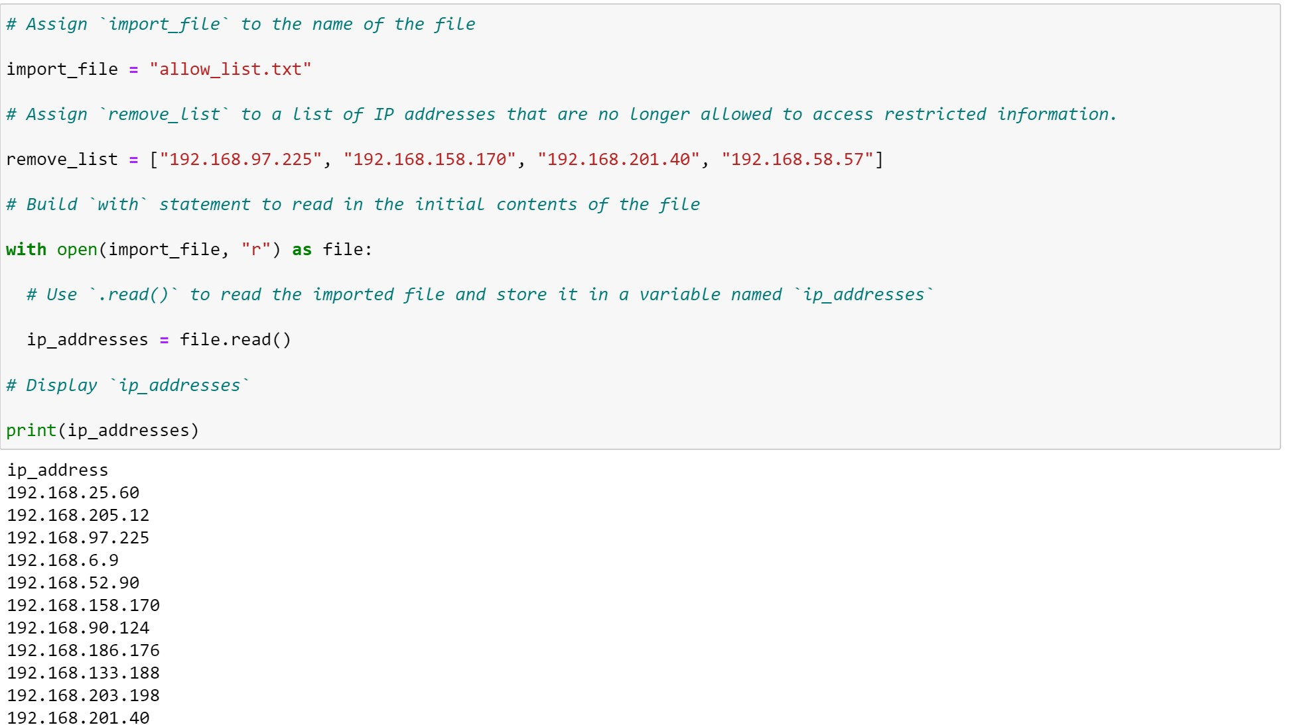

## Read the file contents



## Convert the string into a list

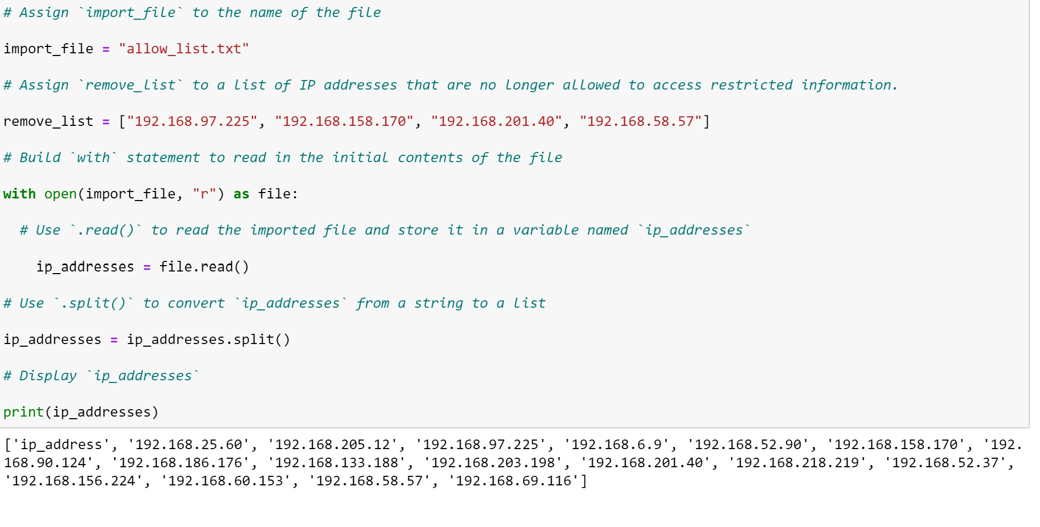

## Iterate through the remove list

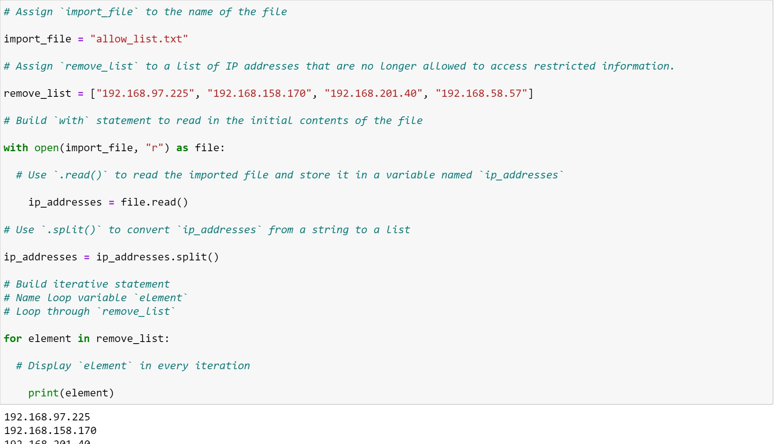

## Remove IP addresses that are on the remove list

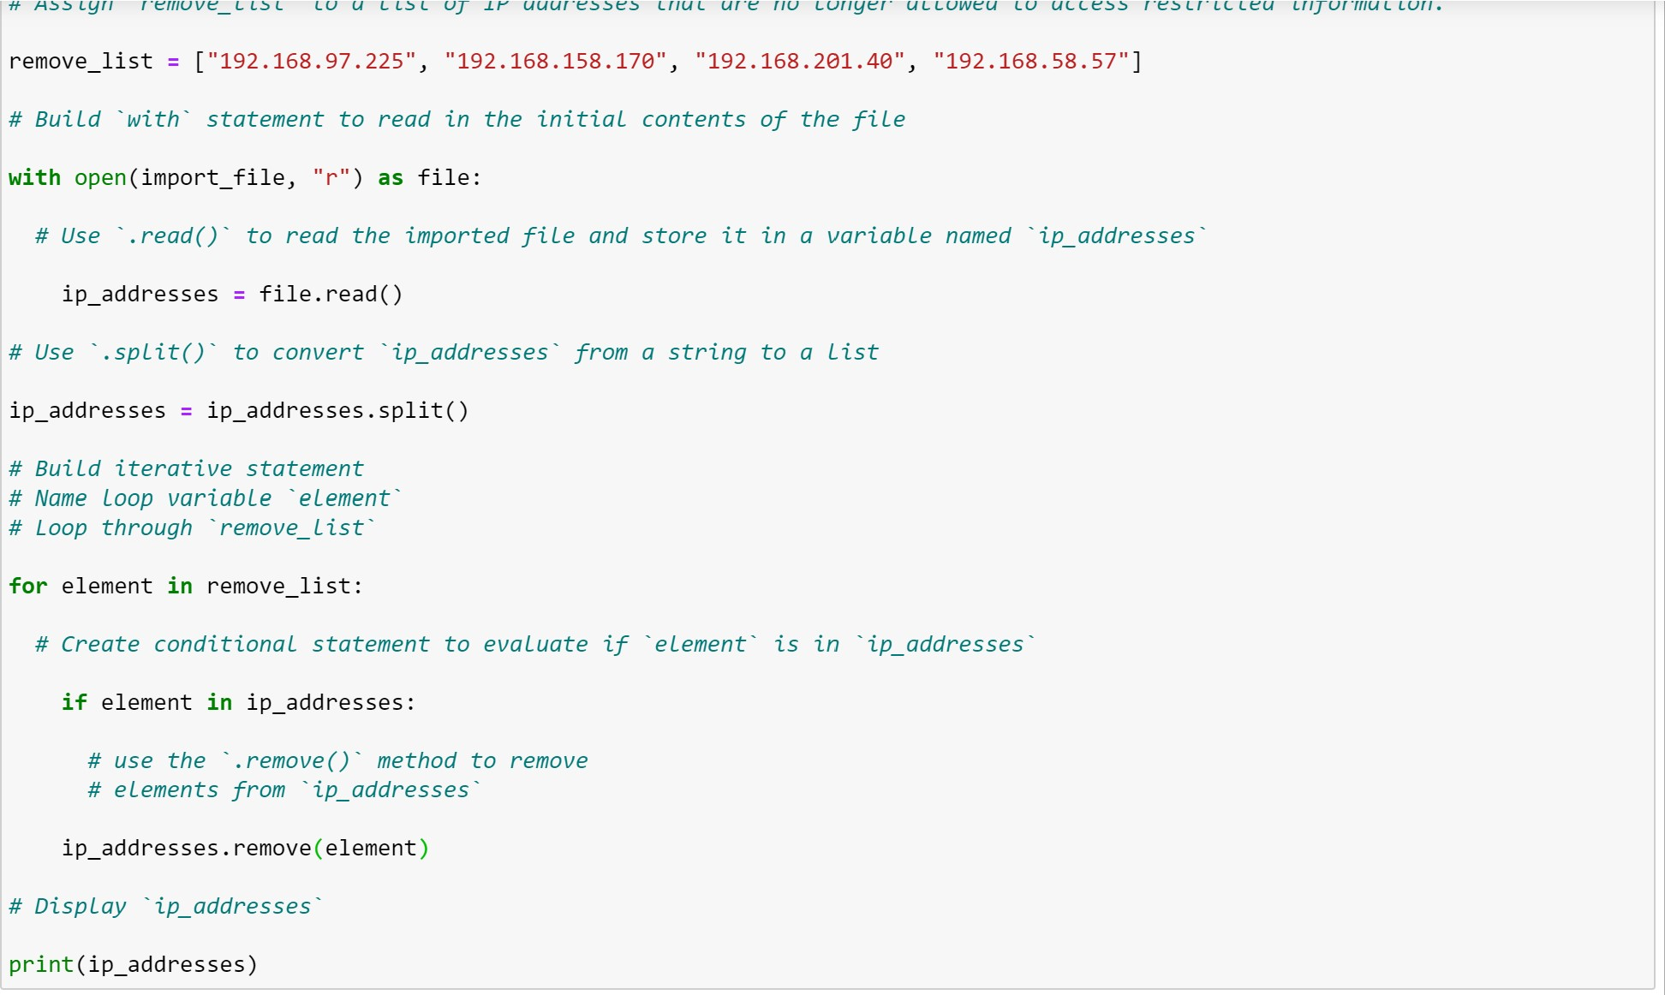

## Update the file with the revised list of IP addresses

